**MOST COMMON LETTERS**

**SEPARATING THE WORDS FROM THE DATABASE INTO ITS 5 POSITIONS:**

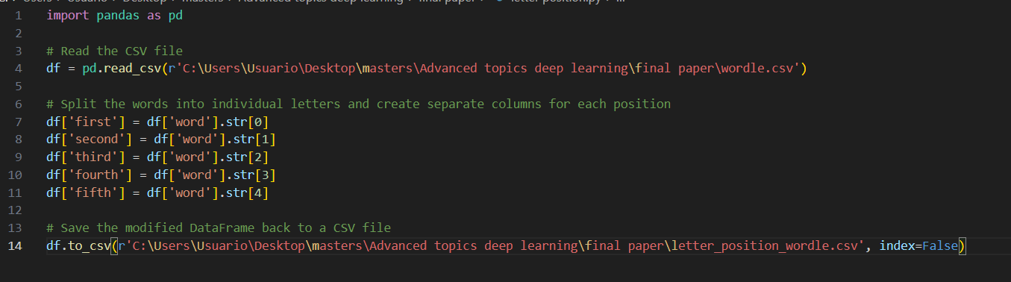

**USING A LANGCHAIN AGENT:**

I attempted to use the langchain csv agent to figure out the most common letters for each position. Even though the agent does seem to understand the prompt it is not able to figure it out itself.

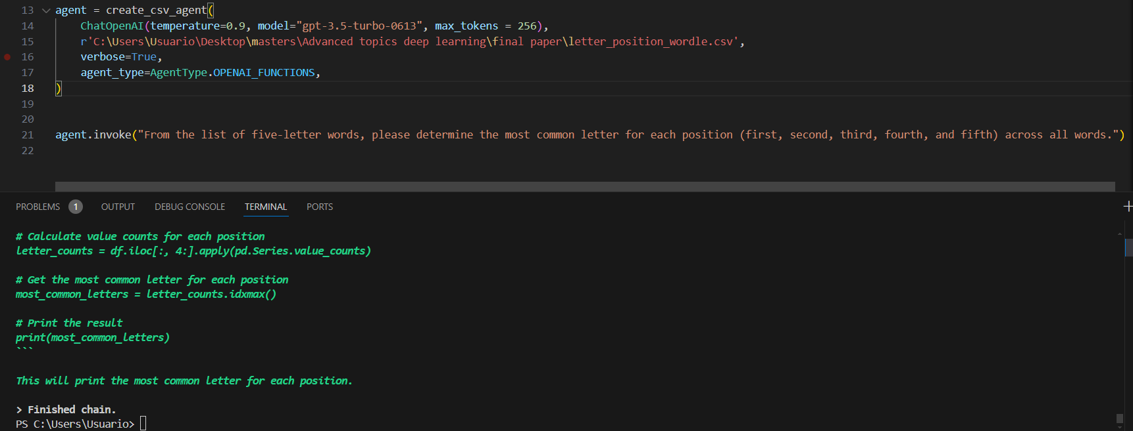

**USING PANDAS:**

Since this was not possible I used pandas to make a txt file with the results:

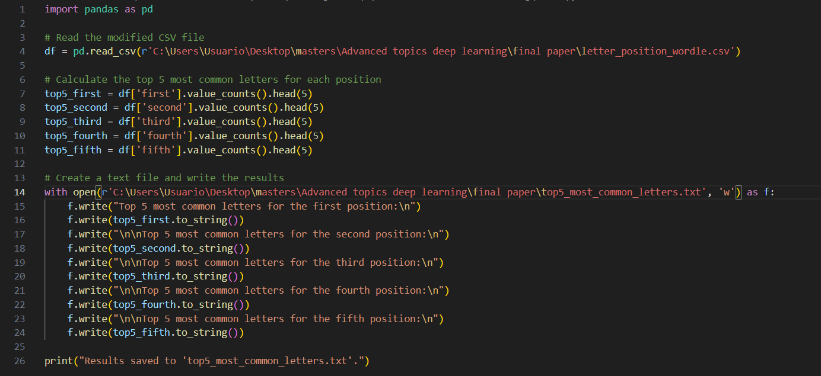

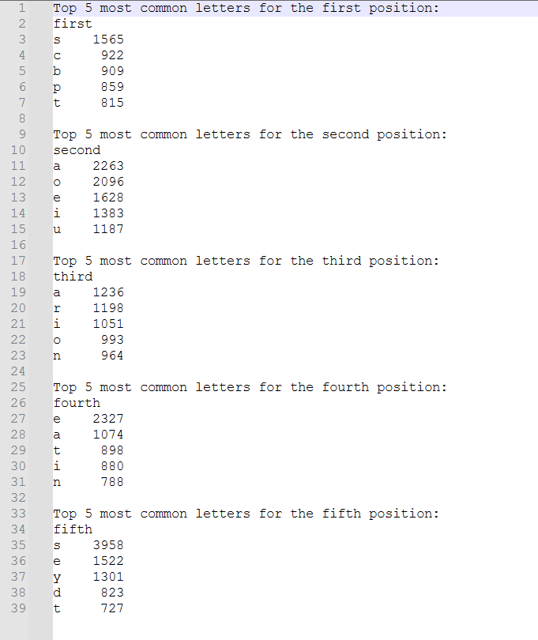

We can now use this information for the prompting.